Sprint 3, D0018E Group 34

# Executive Summary:

DreamTeam Luleå is an e-commerce webstore made in Bootstrap Framework, PHP/JavaScript and SQL, that sells electronic devices / computer equipment. While it is primarily server-side programmed, it takes advantage of some client-side JavaScript to modify data before sending it to the database.

# User Roles:

* Admin (Role for employees that unlocks more permissions)
* Customer

# Scenarios/Use-cases:

* Admin adds a new product
* Admin edits/deletes a product
* Admin views current orders made by customers
* Admin changes user role of a user / deletes a user
* Customer logs in on site
* Customer submits a contact form
* Customer adds products into his/her shopping cart and then checks out
* Customer deletes/clears his/her shopping cart
* Customer views/cancels/clears his/her order(s)
* Customer edits his/her user settings
* Customer edits his/her shipping settings
* An unregistered user makes an account

# Architecture:

* Bootstrap framework for HTML,
* PHP for the Back-end Server interaction,
* JavaScript for the Front-end client interaction,
* MySQL for the database.

We will use PHP to connect the SQL Database with the HTML website, and then use that connection to export and import data to and from the server. We are using JavaScript for client-side interactions. The bootstrap framework is just to make a neat looking website while simplifying the coding process.

GitHub link to code repository: <https://github.com/Mawn/D0018E-Databaser>

# Test-case Specifications (for sprint 3 only):

* Manually add new products via the database and refresh the website to see the changes
* Change product categories on products and filter the products page to show the changes
* Add three products to the cart, and then delete one manually and press ‘Clear Cart’ to empty it
* Change user settings for the logged in account
* Change user role / delete an account (Administrator only)
* Change the amounts on products to show an update in total price and amounts in database
* Register a new account and log in

# E-R Diagram:

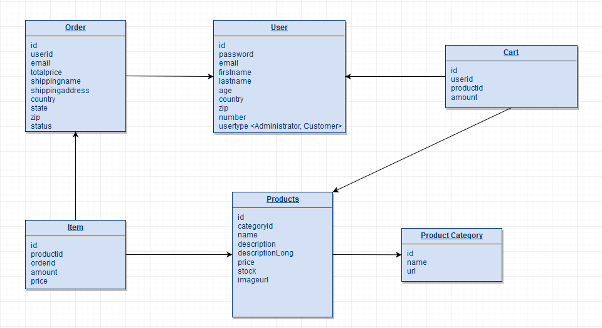

We couldn’t get MySQL Workbench to work on the school computers, so we are still using a draw.io XML Diagram for the E-R Diagram.

# Limitations and Improvements:

Currently you can create a new category in MySQL and a new category will appear in the html code, and while it links to the custom URL given in the “productscategory” table, you need to manually create new HTML/PHP files for it to work.

Improvements from Sprint 2 has mainly been design related and focused on providing a simple user experience while still having the same back-end experience.

# Backlog:

